1.Write a Pandas program to select distinct department id from employees file.

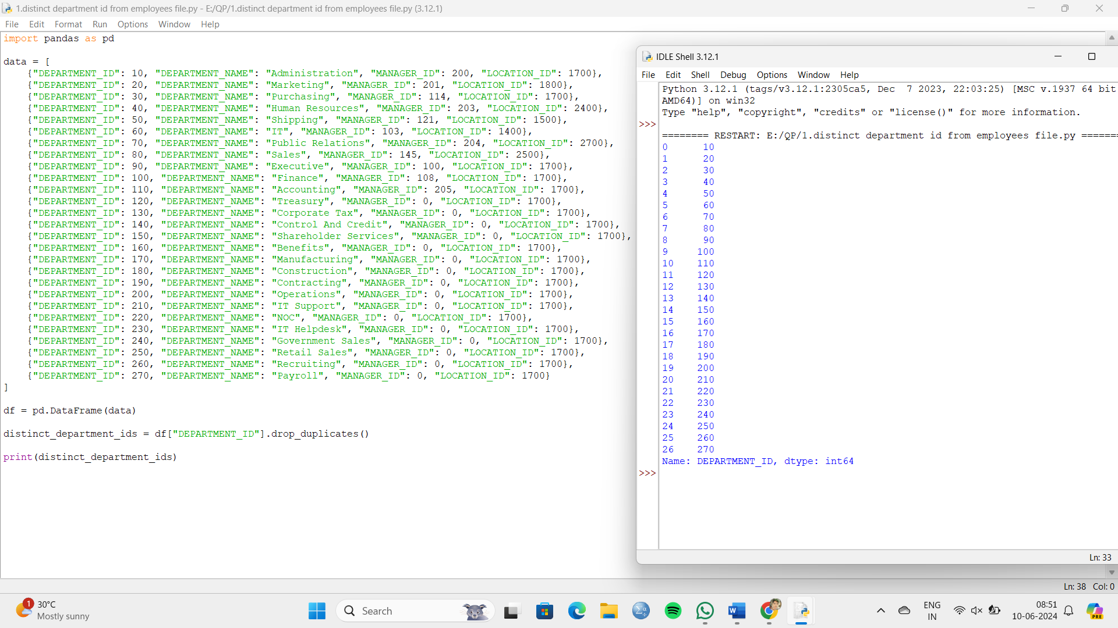

2.Write a Pandas program to display the ID for those employees who did two or more jobs in the past.

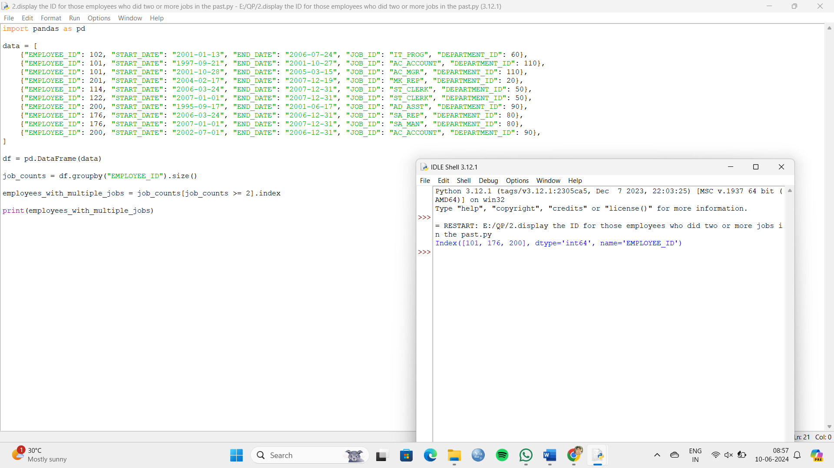

3.Write a Pandas program to display the details of jobs in descending sequence on job title.

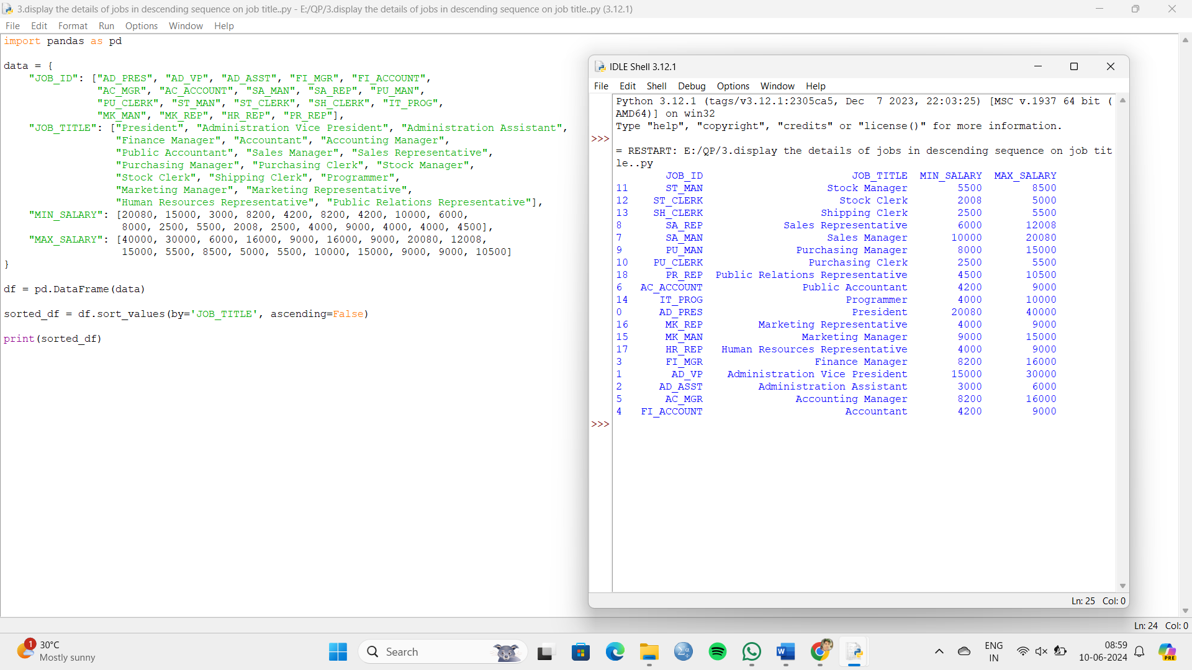

4.Write a Pandas program to create a line plot of the historical stock prices of Alphabet Inc. between two specific dates.

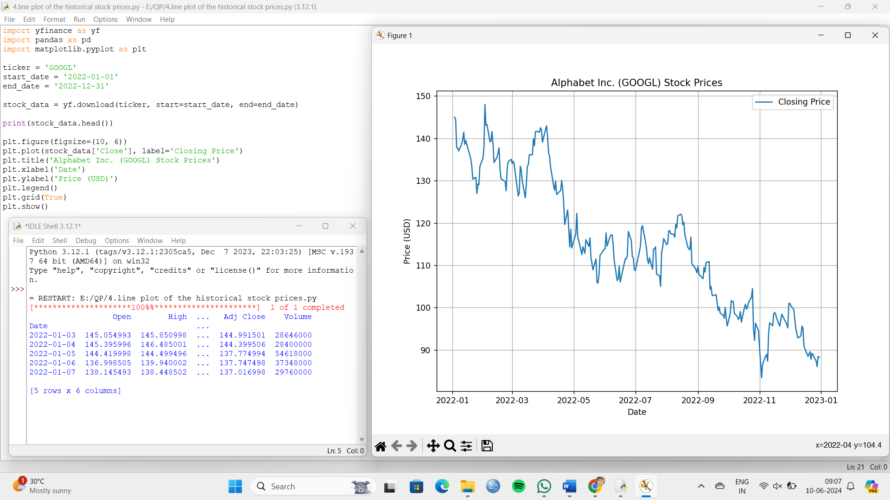

5.Write a Pandas program to create a bar plot of the trading volume of Alphabet Inc. stock between two specific dates.

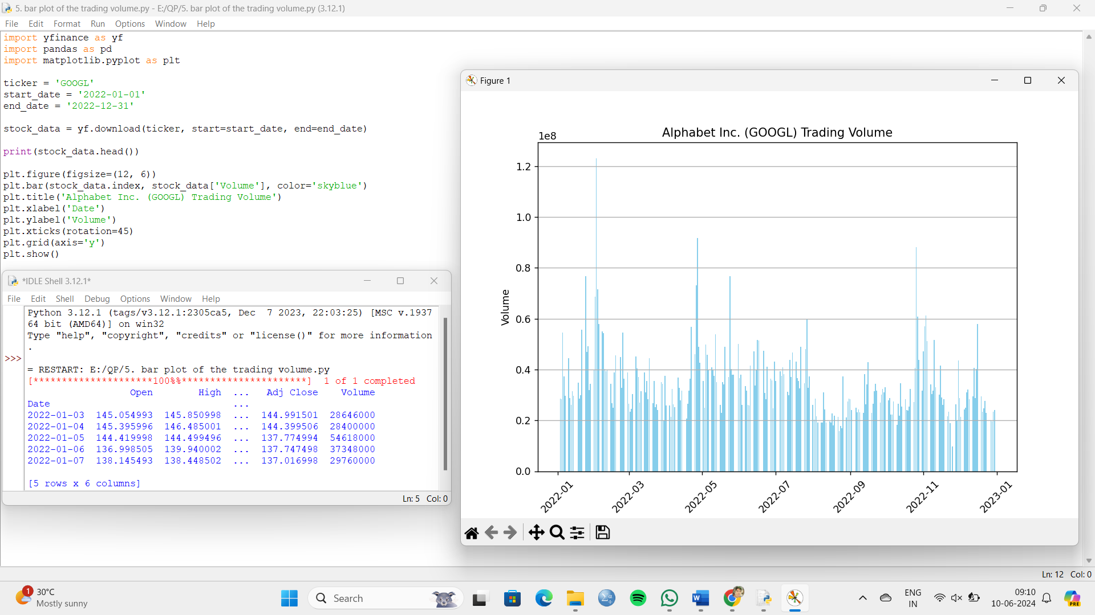

6.Write a Pandas program to create a scatter plot of the trading volume/stock prices of Alphabet Inc. stock between two specific dates.

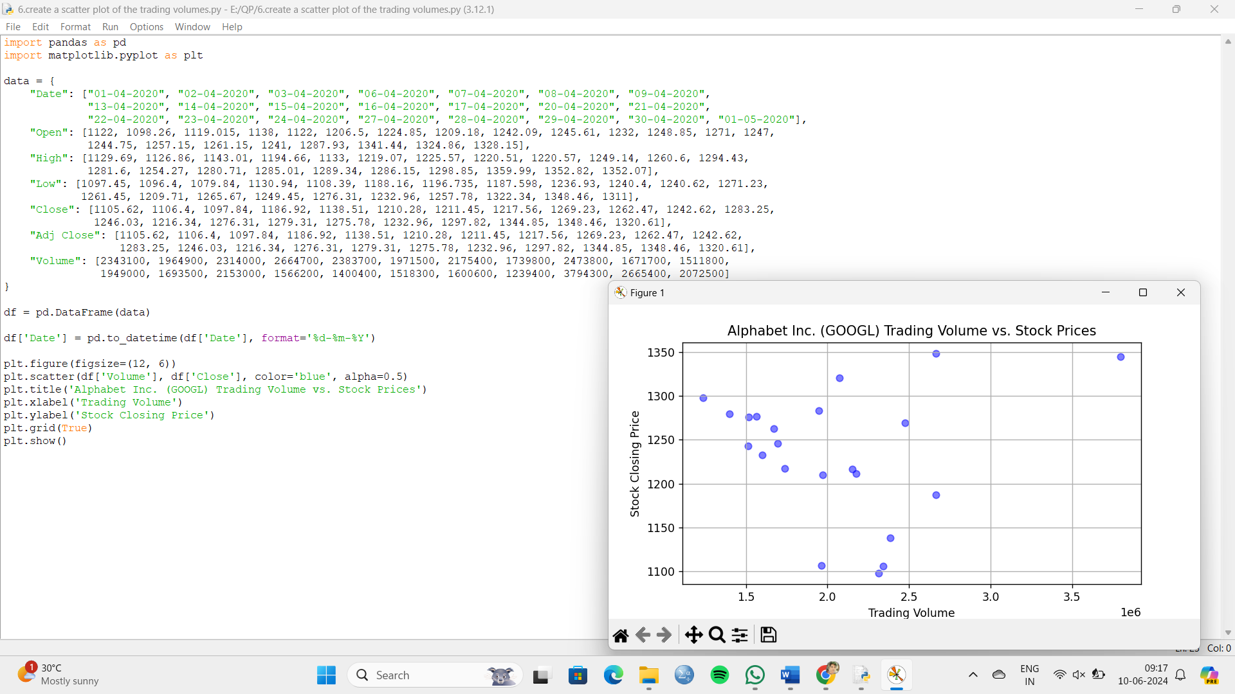

7.Write a Pandas program to create a Pivot table and find the maximum and minimum sale value of the items.(refer sales_data table)

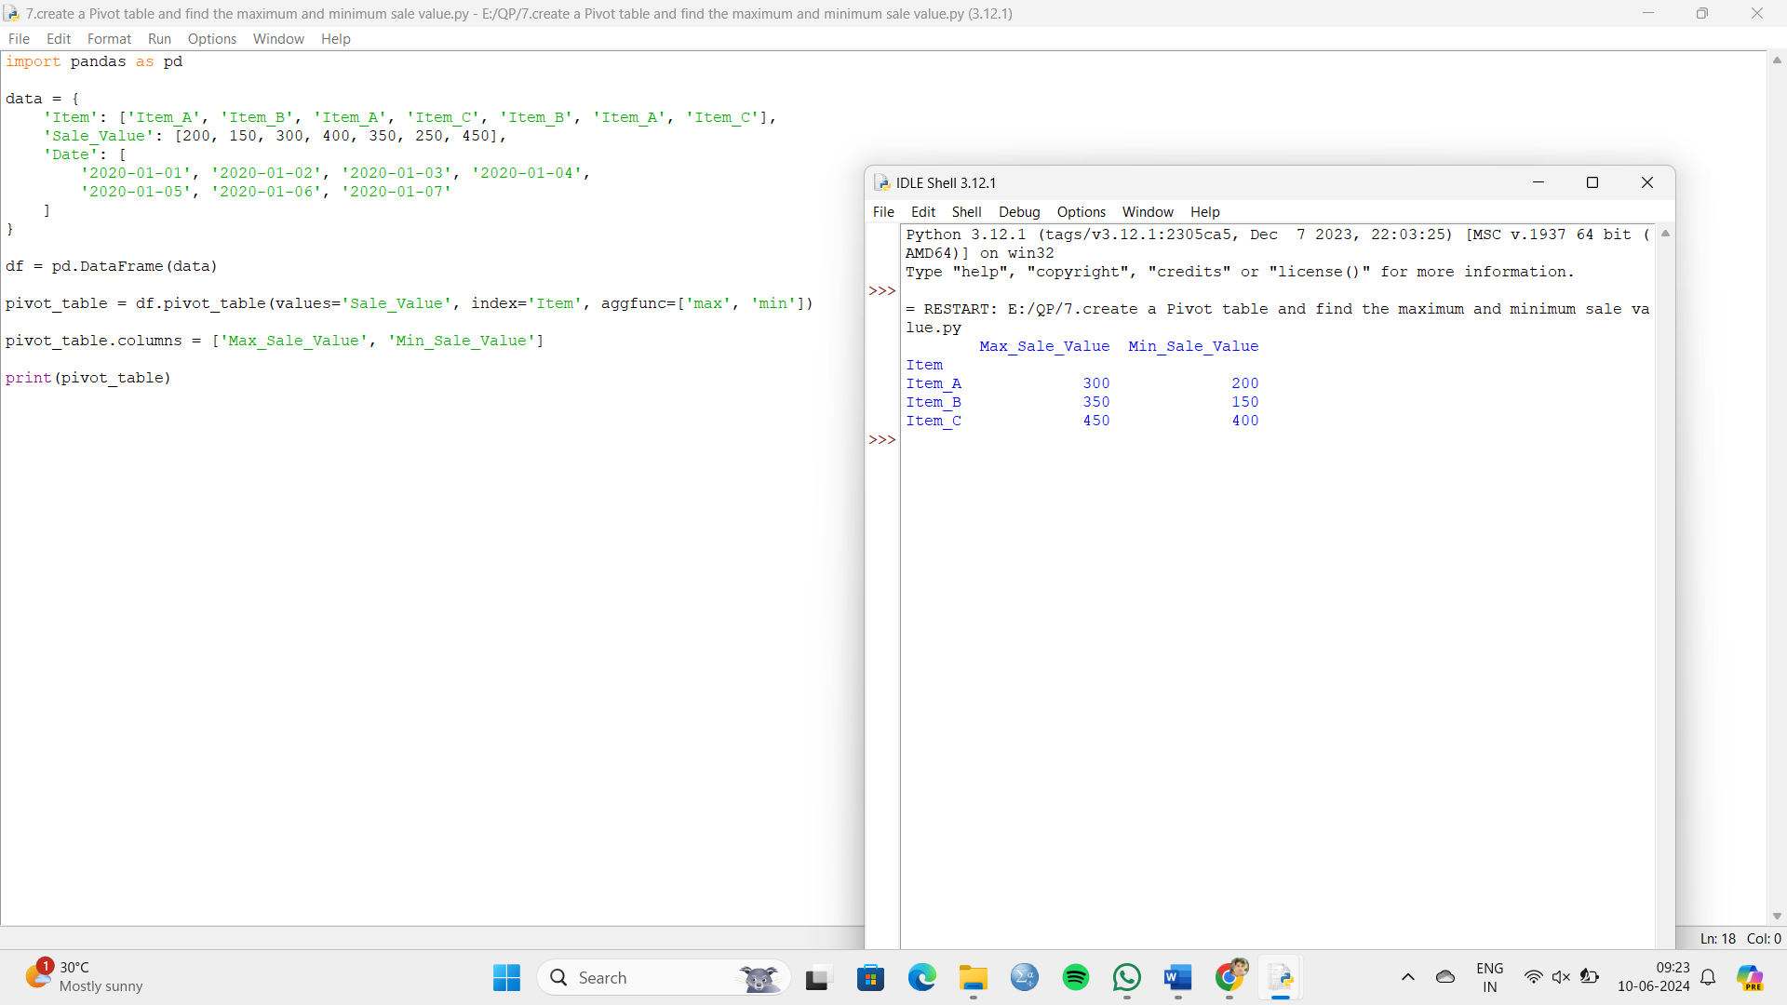

8.Write a Pandas program to create a Pivot table and find the item wise unit sold. .(refer sales_data table)

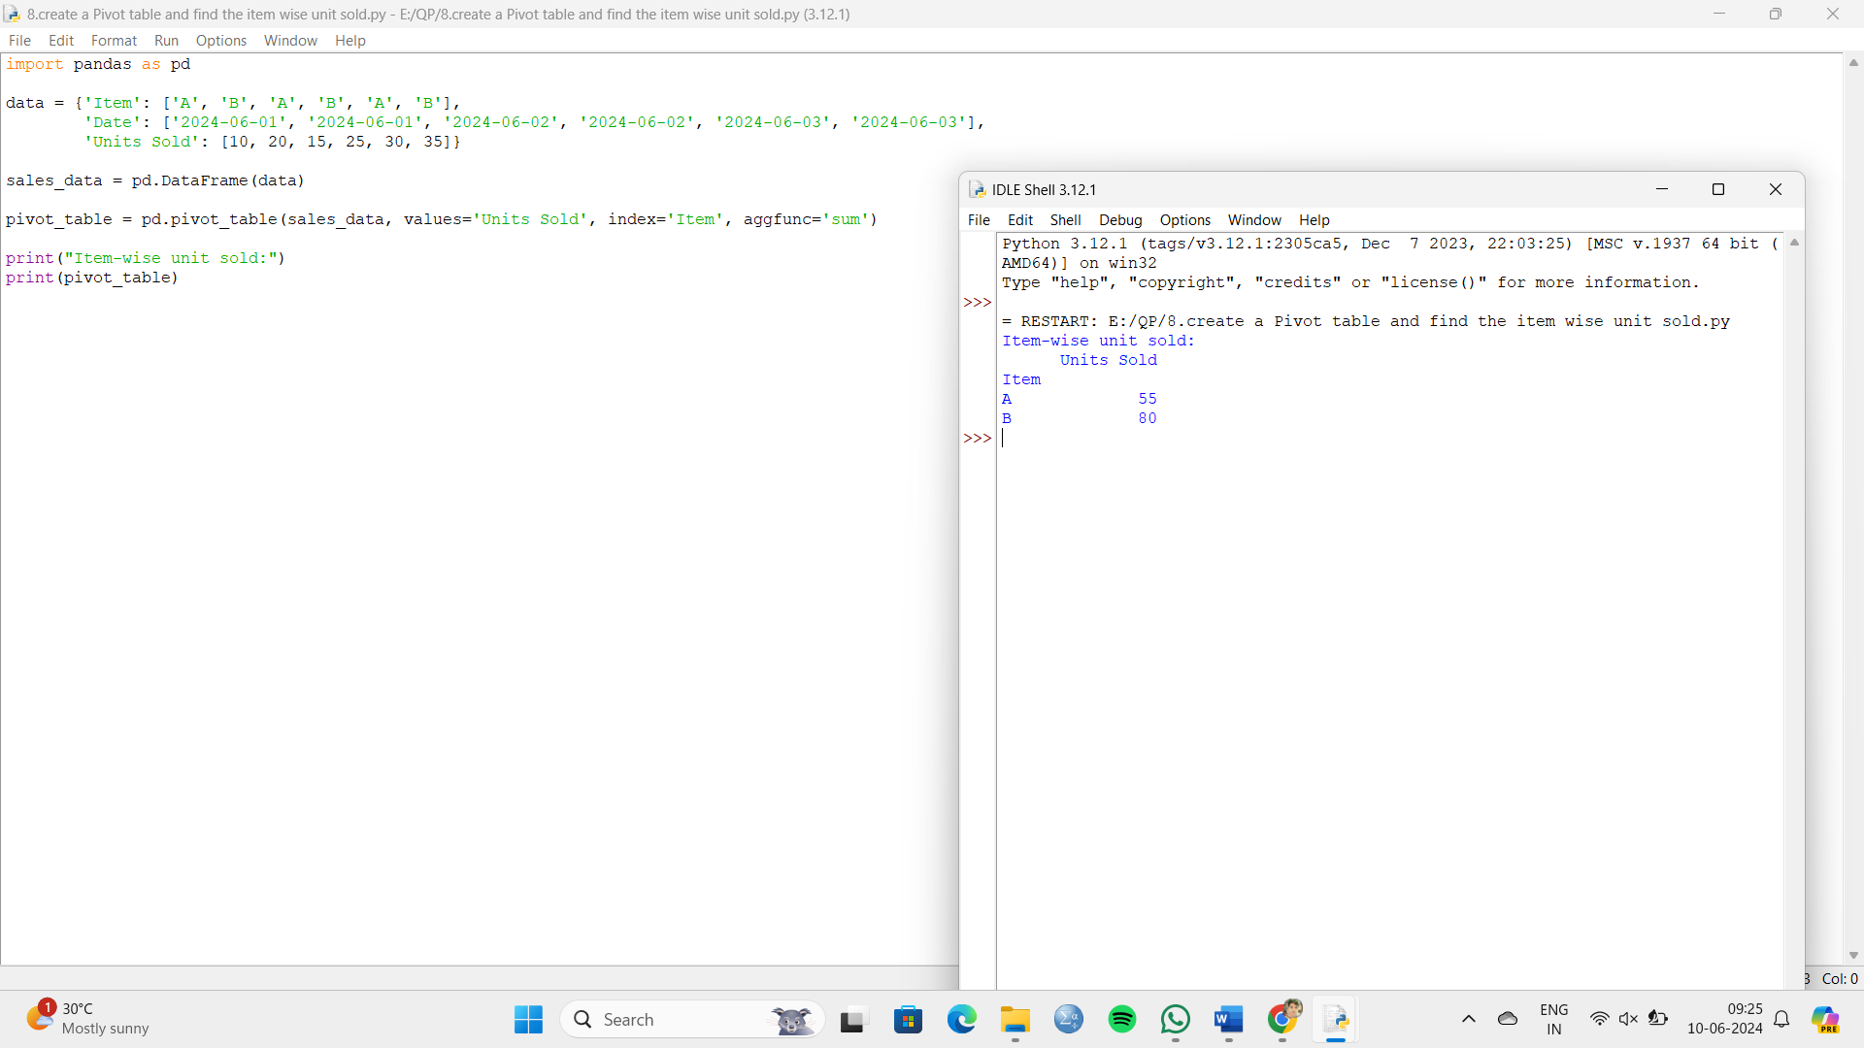

9.Write a Pandas program to create a Pivot table and find the total sale amount region wise, manager wise, sales man wise. .(refer sales_data table)

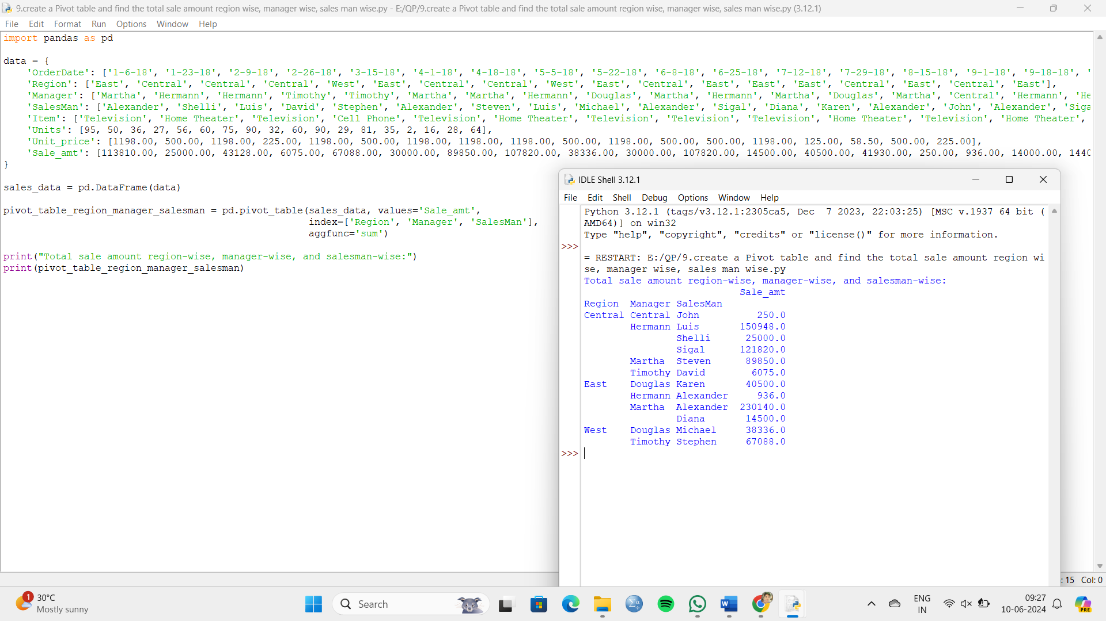

10. Create a dataframe of ten rows, four columns with random values. Write a Pandas program to highlight the negative numbers red and positive numbers black.

